Task 8: Write a MapReduce program that takes the output of Task 5 (refer session 7, assignment 1) as input, and produce output which is sorted on the total units sold. You may use a single reducer for the sorting. Use Sequence File formats as an output of Task 5 and as input for this task.

DRIVER CLASS: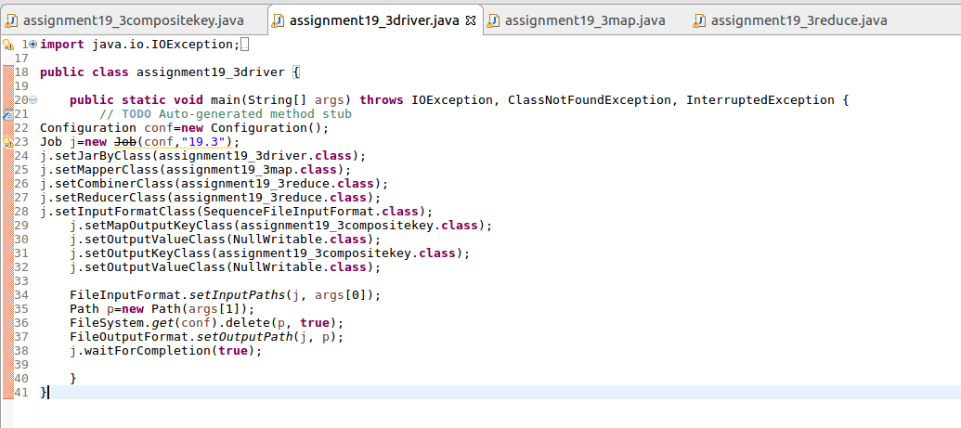

MAPPER CLASS:

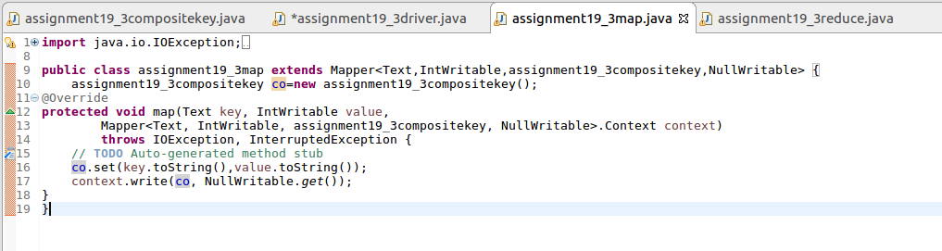

REDUCER CLASS:

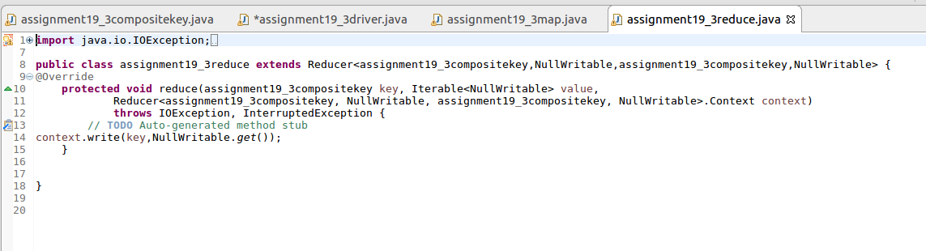

COMPOSITE KEY:

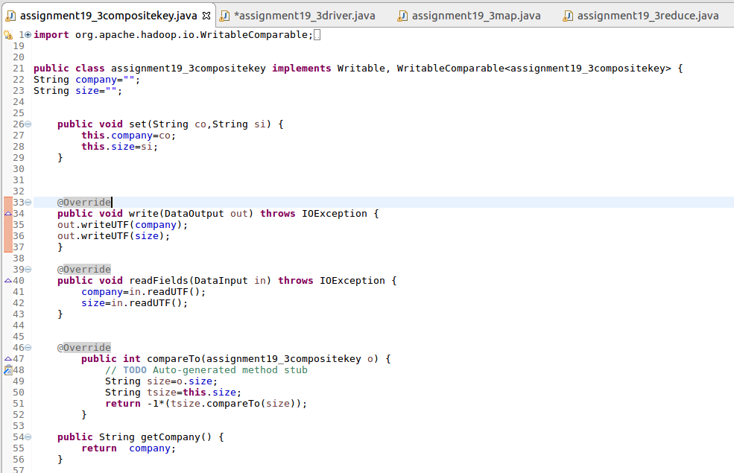

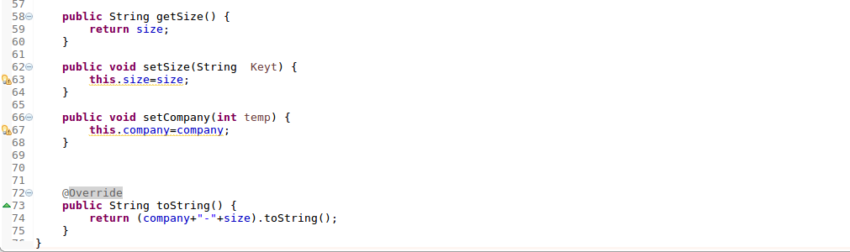

INPUT FILE:

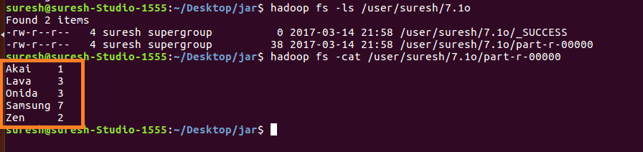

RUNNING JAR:



OUTPUT:  
